THE LIVES AND HALF-LIVES OF RADIOISOTOPES

The nuclei of different radioactive substances decay at different rates. Some radioisotopes decay in a few seconds, while others take thousands of years.

The time taken for half of all the nuclei in a sample of a radioisotope to disintegrate or decay is known as its half-life.

In the graph below, it shows how Strontium-90 decays over time.

Its half-life is 28 years. This means that every 28 years, the amount of radiation detected decreases by one-half.

Note - the amount of radiation detected goes from 1.0 to 0.5, to 0.25, to 0.125, and so on. It keeps halving every 28 years.

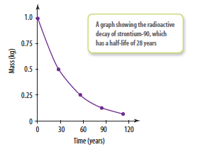

The table below shows how the half-life decreases.

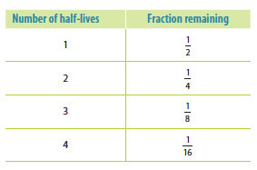
Each isotope has its own half-life; that is, the time taken for the concentration to fall to half its initial value.

Half-life can vary from microseconds to billions of years.

e.g. Beryllium - 11 has a half-life of 13.8 seconds.

Carbon - 14 has a half-life of 5730 years.

Uranium - 238 has a half-life of 4.47 billion years.

